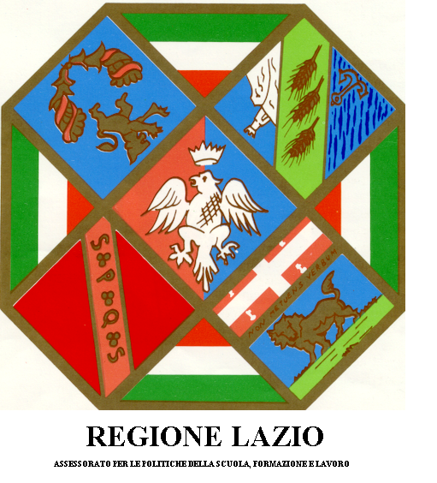
Digital Bridge - A Technological Bridge with Cameroon
Press Videoconference with Fontem
Rome, 10 February 2009, 11:00 am
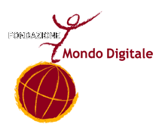
Regione Lazio, Sala Tevere, via Cristoforo Colombo 212

PRESS RELEASE

Digital Bridge: technology for cooperation and development

Even Fontem is on-line

Fontem inaugurates its new Internet connection live with the Lazio Region and various schools in Rome and the authorities, schools and hospital in Fontem. A delegation of Roman students is in Fontem with the Fondazione Mondo Digitale to celebrate the “National Youth Festival”.
For the community of Fontem, in the Lebialem Region of Cameroon, a videoconference is a historical event that will be underlined by the presence of the highest local authorities: the Fon, the Mayor, the Prefect and local school administrators.
The appointment to watch this event live from Rome is set for February 10 at 11:00 am in the Sala Tevere of the Lazio Region. The event will feature addresses by Councillor Mario Michelangeli (Consumer Rights and Administrative Simplification, Lazio Region) and the Vice-President of the Lazio Regional Council Bruno Prestagiovanni will be present in Rome together with the Director General of the Fondazione Mondo Digitale, Mirta Michilli.
Three Roman Schools that contributed to the Digital Bridge project will also participate in the videoconference directly from their schools: B. Russell, I. Kant and the 157th Circolo Didattico in Torrimpietra.
The event will be coordinated by Lats Vice-President Paul Ntemgwa with the organisational support of Martin Nkafu, Professor of Culture, Religion and African Thought at the Gregorian and Lateran Pontifical Universities. The event will also feature other elements, including musical performances, from both Rome and Fontem.
Moreover, on February 8-16, a delegation of nine students and six teachers from the three schools participating in the Digital Bridge Project will be on a “special mission” to Fontem. The schools, together with the associations that operate in Fontem, are involved in fair cooperation projects and are designing a development community. The National Youth Festival, which will be celebrated every year on February 11th, will allow Roman and African students to celebrate the country’s independence and the advent of a new development phase for the Region of Lebialem.
The operative digital and social inclusion plan for Cameroon is financed by the Lazio Region, coordinated by the Fondazione Mondo Digitale and implemented in situ by Azione per un Mondo Unito onlus (AMU), Scuole in Rete di Roma (SIR), Lebialem Association for Twinning of Schools (LATS) and Act Now Alliance with the collaboration of the European Space Agency (ESA).
The satellite connection system and the local wi-fi network have been designed to operate in the peculiar climactic conditions of the Lebialem Region. All the system components are rugged, repairable, recyclable and pose a low environmental impact. Moreover, before being shipped to Lebialem, every element was tested for conformity and stability at the Frascati branch of the European Space Agency (Esrin). This original and sustainable solution is now being studied as a reference model for other project employing satellite technology in Africa.
Besides its technical aspect, the Digital Bridge Project also addresses three other areas of development: educational-didactics, informative-educational and management. All four areas are fully operational both in Cameroon and Saharawi.
Documents, photos and video clips on the project can be accessed at www.mondodigitale.org

Rome, 10 February 2009
Press Office: Fondazione Mondo Digitale
Tel. 06 42014109, cell. 392 8664584 or 349 5937697, e.amorelli@mondodigitale.org

