TRANSNATIONAL SEMINAR

EUROPEAN PROJECT

“EUROPEAN RESOURCES MANAGER OF SCHOOL CITIES”

Barcelona, 27-28 November 2008

AGENDA
27 November 2008

Venue:
Institut Municipal d’Educació de Barcelona (IMEB)
Plaça d’Espanya, 5
Conference Room (1st floor)

How to get there: Metro Lines 1 and 3. Buses: 9, 13, 23, 27, 30, 50, 56, 57, 61, 109 http://www.bcn.cat/guia

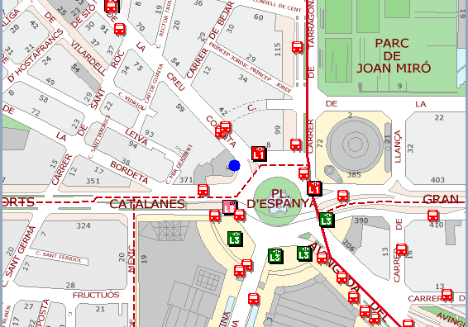

12 noon Reception of participants and documentation handed over.

12.15-12.30 Welcome by Antònia Hernández, Director of Education Promotion and Territorial Distribution, IMEB.

13.00-15.00 Lunch

15.30-17.30 Guided tour of some of the emblematic spots of Barcelona’s Gothic quarter, organized by Itineraplus.

Venue:
Palau de la Virreina
La Rambla, 99
Room 4 (4th floor)

18.00 Welcome by Montserrat Ballarín, Barcelona City Councillor for Education.

18.15-19.15 Conference: How can ICTs be used to inform teachers about the educational activities available in the city? By Jordi Vivancos, Head of the Learning and Knowledge Technology Service of the Catalan Government’s Department of Education.

21.00 Welcome dinner offered by Barcelona Municipal Institute of Education (IMEB).

AGENDA
28 November 2008

Venue:

Ajuntament de Barcelona - Sector d’Urbanisme
(Barcelona City Council - Urban Development)
Avinguda Diagonal 240
Sala Barcelona (2nd floor)

How to get there: Metro Line 1. Buses: 56, 60, 92, 192. http://www.bcn.cat/guia

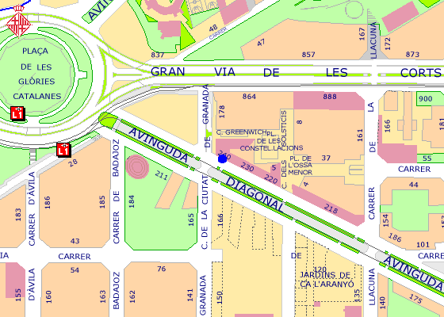

09.15 Reception of participants and documentation handed over.

09.30-10.45 Analysis of results obtained during the validation phase of the European Resources Manager. The cities of Barcelona, Copenhagen, Gijón, Rome and Rotterdam will present their results (anticipated time for each city’s intervention: 15 minutes).

10.45-11.15 Coffee break

11.15-12.15 Analysis of results obtained during the validation phase of the European Resources Manager. The cities of Sabadell, São João da Madeira, Trento and Veliko Turnovo will present their results (anticipated time for each city’s intervention: 15 minutes).

12.15-12.45 Presentation of the European Resources Manager validation report by the city of Barcelona.

Debate and consensus: all partners.

12.45-13.00 Presentation of the action taken to disseminate the project, by the representatives of the city of Gijón.

Debate and consensus: all partners.

13.00-13.30 Administrative aspects of the project.

Debate and consensus: all partners

13.30-15.30 Lunch

15.30-15.45 Presentation of the results of the internal project evaluation, by the city of Copenhagen.

15.45-17.15 External project evaluation workshop, by Atos Consulting.

17.15-18.15 Project-partner interviews, by Atos Consulting.

